**Kickstarted campaign report**

1. **Conclusions**

By Analyzing the outcomes for each category, we can notice that the data is unbalanced between categories. There are more kickstarter in entertainment (Theater, Music and Film & Video) categories than all others with Theater being the majority. We can notice that the music category has the highest success rate, and food has the lowest. However, there seems to be no major difference in success rate between categories

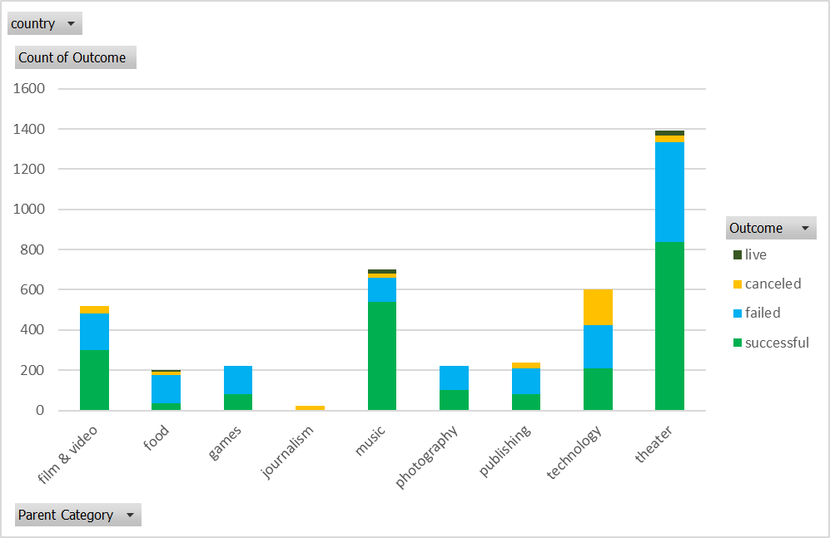

In the sub-categories, we can notice that the majority is plays which contributes more than 5 times the second major sub-category. We notice some sub-categories with 100% success as well as some with 0 success

By analyzing the outcome throughout the year, we can notice that the success rate drops in the summer ad picks up near the end of fall, during winter and spring, while the failed kickstarters drops in the fall and winter and picks up in spring and summer. The canceled kickstarters are static throughout the seasons

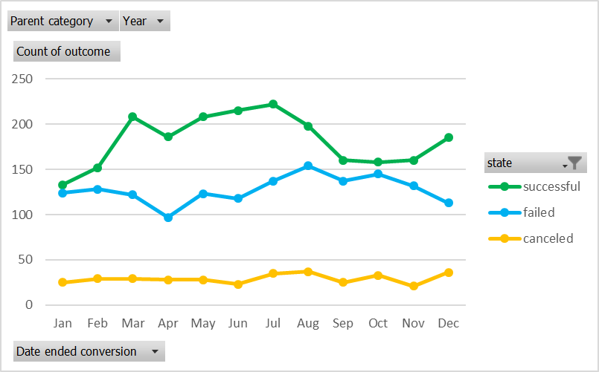

1. **Limitations of the datasets**

The major limitation of this dataset is that there was no explanation of the dataset, no explanation of the columns and the data they store.

1. **Possible explorations**

We could analyze the trend of outcomes based on the Goal of the kickstarter. It would allow us to see if or not higher goals are more likely to fail.

We could also analyze the length of the period vs the pledged. This analysis would help understand whether kickstarters that last longer would have better chance of succeeding, and also predict what would be a good period length based on the goal.